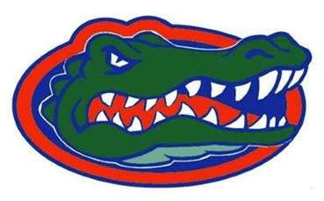
Lakeland Gators
Youth Football &
Cheerleading Association

Sponsorship Application

Diamond Sponsor - $2500 and up
- Benefits are negotiable…..

Platinum Sponsor - $1000
- 3’x5’ banner to be displayed at home games
- Business mention in award banquet program
- Business logo displayed at entrance gate
- Your business mention during all home games
- Invitation to annual Award banquet
- Link to your website on LakelandGators.com
- Monthly social media blasts

Gold Sponsor - $500
- Business mention in award banquet program
- Business logo displayed at entrance gate
- Your business mention during all home games
- Invitation to annual Award banquet
- Link to your website on LakelandGators.com
- Monthly social media blasts

Silver Sponsor - $100
- Your business mention during all home games
- Invitation to annual Award banquet
- Link to your website on LakelandGators.com
- Monthly social media blasts

Bronze Sponsor - $50
- Link to your website from LakelandGators.com
- Monthly social Media blasts

Equipment Sponsor
(Donation of company branded equipment)
- Serves as advertisement for life of equipment
- Invitation to annual Award banquet
- Link to your website on LakelandGators.com
- Monthly social media blasts

Contact the Lakeland Gators for current needs.
(863) 944-1124
lakelandgators65@gmail.com
www.lakelandgators.com

------------------------------------------------------------------------------------------------------------------------------------------------------------------------------------

I, __________________________________, the undersigned, representing ______________________________________________, wish to sponsor the Lakeland Gators Football and Cheerleading Program.

Authorized Signature _______________________________________ Date _______________________

Print Name as Signed _______________________________________ Amount ____________________
_____ Ad Emailed _____Copy of Ad Enclosed _____ Same as Last Year

Name of Business / Sponsor _____________________________________________________________
Mailing address:_______________________________________________________________________
City: ___________________________ State: _____ Zip: __________ Phone: ___________________ __
Email:___________________________________________________

Remit Payments To: Lakeland Gators Youth Athletic Association, Inc. PO Box 6963, Lakeland, FL 33807,
Ads and logos can be emailed to lakelandgators65@gmail.com

Office Use Only: Received:

Payment & Logo _______________________ Receipt Sent _______________________ Plaque Ordered _______________________Plaque Sent ______________

